Agency CRM - Application System

Operating Manual for Infrastructure

Contents

1 Overview of Application 4

1.1 Application Name 4

1.2 EIM ID 4

1.3 Major Business functions 4

1.4 Online Service hours 4

1.5 Batch processing Windows 4

1.6 Scheduled Maintenance Windows 4

1.7 Data Backup Windows 4

1.8 Regular Change/Release schedule 5

1.9 Support and Escalation Contact List 5

2 Normal Operation procedures 6

2.1 System Start-up procedures (Full) 7

2.2 System Shutdown procedure (full) 10

2.3 Respective component start-up procedures 14

2.3.1 Name of components 14

2.4 Respective component Bring-down procedures 14

2.4.1 Name of components 14

2.5 Special Service Recovery Procedures (Full) 14

2.5.1 UP Stream / Down-Stream dependency (Before recovery) 14

2.5.2 Service recovery procedures 15

2.5.3 Verification procedures after recovery 15

2.5.4 UP Stream / Down-Stream dependency (After recovery) 15

2.6 Special Service Recovery Procedures (Name of Component) 15

2.6.1 UP Stream / Down-Stream dependency (Before recovery) 15

2.6.2 Service recovery procedures 15

2.6.3 Verification procedures after recovery 15

2.6.4 UP Stream / Down-Stream dependency (After recovery) 15

3 Data Backup and Archive requirements 16

3.1 Data Archive requirements 16

3.2 Data Backup requirements 16

3.3 Data backup procedures 16

3.4 Data Restoration procedure 16

4 Application Monitoring Requirements 17

4.1 Infrastructure Monitoring and Alerts 17

4.1.1 Items to be monitored and alert thresholds 17

4.1.2 Alert Notification List 17

4.2 Application Monitoring and Alerts 17

4.2.1 Items to be monitored and alert thresholds 17

4.2.2 Alert Notification List 17

4.2.3 Monitoring and Investigation Mechanism 18

# Overview of Application

## Application Name

* Agency CRM

## EIM ID

* HKG2019121000100328

## Major Business functions

* Agency CRM allows agents to search and view their own customer and policy data from mobile phones and iPads. Accessible data includes customer contact information, policy details and coverage, customer family relationship, claim records, etc.
* The data is extracted from EDW in a daily basis and cached in Azure SQL DB and Azure Redis Cache. Since the data is read only, and there is no transaction by end users (i.e. Agent). When the Agency CRM backend is down, this impact to agents cannot retrieve customer and policy information.

## Online Service hours

* Internet facing application
  + Non-productions: 14 * 365 (i.e. available during 8am to 10pm)
  + Production: 24*365 hours

## Batch processing Windows

* N/A

## Scheduled Maintenance Windows

* N/A

## Data Backup Windows

|  |  |  |
| --- | --- | --- |
| Database | Type | Requirements |
| db_smart | Azure SQL Database | Follow the backup windows below |
| Cache | Azure Redis Cache | Backup is not required; the data can be recached during the normal usage |

**Prod：**

|  |  |
| --- | --- |
| Backup Frequency | Point in time backup for 35 days |
|  |  |
| Retention of Weekly backup point | Retain backup for 6 weeks |
| Retention of Monthly backup point | Retain backup for 13 Month(s) |
| Retention of yearly backup point | Retain backup Keep week1 for 8 Year(s) |

**UAT：**

|  |  |
| --- | --- |
| Backup Frequency | Point in time backup for 35 days |
|  |  |
| Retention of Weekly backup point | Retain backup for 8 weeks |
| Retention of Monthly backup point | Retain backup for 6 Month(s) |

**SIT：**

|  |  |
| --- | --- |
| Backup Frequency | Point in time backup for 35 days |
|  |  |
| Retention of Weekly backup point | Retain backup for 8 weeks |

## Regular Change/Release schedule

* N/A

## Support and Escalation Contact List

|  |  |  |  |  |  |  |
| --- | --- | --- | --- | --- | --- | --- |
| Application | Primary Support Name | Primary Support Email Address | Primary Support Contact No. | Secondary Support Name | Secondary Support Email Address | Secondary Support Contact No. |
| CRM | Wong, Rosa-PS | [rosa-ps.wong@aia.com](mailto:rosa-ps.wong@aia.com) | +852 2881 3265 | Darryl, Lau | darryl.lau@aia.com |  |

# Normal Operation procedures

Overall environment information for reference:

|  | DEV | SIT | UAT | PROD | DR | Regression |
| --- | --- | --- | --- | --- | --- | --- |
| **D365** |  | https://aia-hk-salecampaign-sit.crm5.dynamics.com/ | https://aia-hk-salecampaign-uat.crm5.dynamics.com/ | https://aia-hk-salecampaign.crm5.dynamics.com/ | NA | NA |
| **BDM** | 10.202.159.7 | NA | 10.202.220.25 | 10.202.92.25  10.202.92.26 | NA | NA |
| **ADF** | dfhk01easdshared01d36501 | dfhk01eassshared01crm01 | dfhk01easushared01crm01 | dfhk01easpshared01crm01 | dfhk01easrshared01crm01 | dfhk01easgshared01crm01 |
| **IR VM** | HKAZEDWAP0103 (10.202.158.11) | HKAZESWAP0103 (10.202.188.32) | HKAZEUWAP0103 (10.202.220.32) | HKAZEPWAP0104 (10.202.92.32) | NA | HKAZEGWAP0103 (10.202.252.18) |
| **IR** | AIA-HK-SmartETL-DEV-ADF-IR | AIA-HK-SmartETL-SIT-ADF-IR | AIA-HK-SmartETL-UAT-ADF-IR | AIA-HK-SmartETL-PRD-ADF-IR | NA |  |
| **Autosys Client**  **BDM Client** | 10.202.129.20 (no autosys client, only BDM client) | 10.202.159.3  (no autosys client, only BDM client) | 10.202.220.21 | 10.202.92.22 | NA | NA |
| **Azure Blog Storage** | sahk01easdshared01crm01 | sahk01eassshared01crm01 | dfhk01easushared01crm01 | dfhk01easpshared01crm01 | NA | dfhk01easgshared01crm01 |
| **AIA Smart Key Vault** | kv-hk01-eas-d-se-vlt01 | kv-hk01-eas-s-se-vlt01 | kv-hk01-eas-u-se-vlt01 | kv-hk01-eas-p-se-vlt01 | kv-hk01-sea-r-se-vlt01 | kv-hk01-eas-g-se-vlt01 |
| **Azure SQL (db_smart)** | sql-hk01-eas-d-infrasvc01-srv01/db_smart | sql-hk01-eas-s-infrasvc01-srv01/db_smart | sql-hk01-eas-u-infrasvc01-srv01/db_smart | sql-hk01-eas-p-infrasvc01-srv01/db_smart | sql-hk01-sea-r-infrasvc01-srv01/db_smart | sql-hk01-eas-g-infrasvc01-srv01/db_smart |
|  | sql-hk01-eas-d-infrasvc01-srv01.database.windows.net | sql-hk01-eas-s-infrasvc01-srv01.database.windows.net | sql-hk01-eas-u-infrasvc01-srv01.database.windows.net | sql-hk01-eas-p-infrasvc01-srv01.database.windows.net | sql-hk01-sea-r-infrasvc01-srv01.database.windows.net | sql-hk01-eas-g-infrasvc01-srv01.database.windows.net |
| **Redis Cache** | redhk01easdshared01crm01.redis.cache.windows.net | redhk01eassshared01crm01.redis.cache.windows.net | redhk01easushared01crm01.redis.cache.windows.net | redhk01easpshared01crm01.redis.cache.windows.net | redhk01searshared01crm01.redis.cache.windows.net | redhk01easgshared01crm01.redis.cache.windows.net |
| **Redis resource group** | rg-hk01-eas-d-digital01-storage02 | rg-hk01-eas-s-digital01-storage02 | rg-hk01-eas-u-digital01-storage02 | rg-hk01-eas-p-digital01-storage02 | rg-hk01-eas-r-digital01-storage02 | rg-hk01-eas-g-digital01-storage02 |
| **Redis subnet** | subnet-d-infrasvc01-redis01-10.202.144.64-28 | subnet-s-infrasvc01-redis01-10.202.160.128-28 | subnet-u-infrasvc01-redis01-10.202.192.128-28 | subnet-p-infrasvc01-redis01-10.202.66.128-28 | subnet-r-infrasvc01-redis01-10.202.98.128-28 | subnet-g-infrasvc01-redis01-10.202.224.128-28 |
| **Redis IP Address** | 10.202.144.13 | 10.202.160.136 | 10.202.192.133 | 10.202.66.138 | 10.202.98.138 | 10.202.224.141 |
| **AKS** | aks-hk01-eas-d-internet-cu03 | aks-hk01-eas-s-internet-cu03 | aks-hk01-eas-u-internet-cu03 | aks-hk01-eas-p-internet-cu03 | aks-hk01-sea-r-internet-cu03 | aks-hk01-eas-g-internet-cu03 |
| **AKS  resource group** | rg-hk01-eas-d-internet-cont01 | rg-hk01-eas-s-internet-cont01 | rg-hk01-eas-u-internet-cont01 | rg-hk01-eas-p-internet-cont01 | rg-hk01-sea-r-internet-cont01 | rg-hk01-eas-g-internet-cont01 |
| **AIA Smart Key Vault** | kv-hk01-eas-d-se-vlt01 | kv-hk01-eas-s-se-vlt01 | kv-hk01-eas-u-se-vlt01 | kv-hk01-eas-p-se-vlt01 | kv-hk01-sea-r-se-vlt01 | kv-hk01-eas-g-se-vlt01 |
| **Linux deployment VM** | 10.202.129.8 | 10.202.129.8 | 10.202.129.8 | 10.202.129.8 |  |  |
| **Windows deployment VM** | 10.202.159.3 | 10.202.159.3 | HKAZEUWAP0101 (10.202.220.21) | HKAZEPWAP0101 (10.202.92.22) |  |  |

## System Start-up procedures (Full)

1. Remote desktop to Windows jump Host (for example, 10.202.129.5) from terminal server
2. Login Linux jump host (for example, 10.202.129.8) with tool Putty using account of linux jump host.

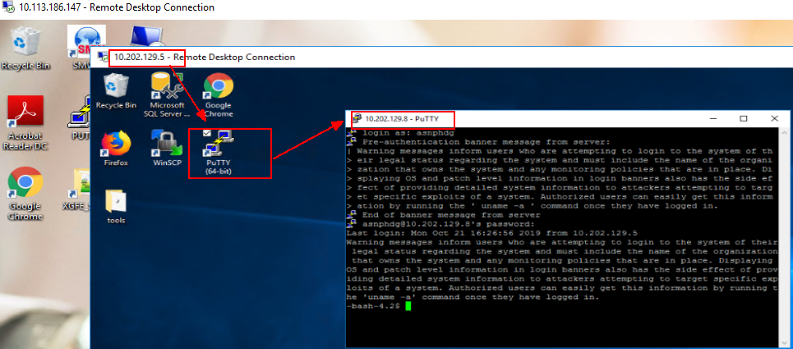

1. Azure device login
2. Run command : **az login**
3. Open Google Chrome and input URL <https://microsoft.com/devicelogin> , copy code from console and input to UI page, then click Next button.

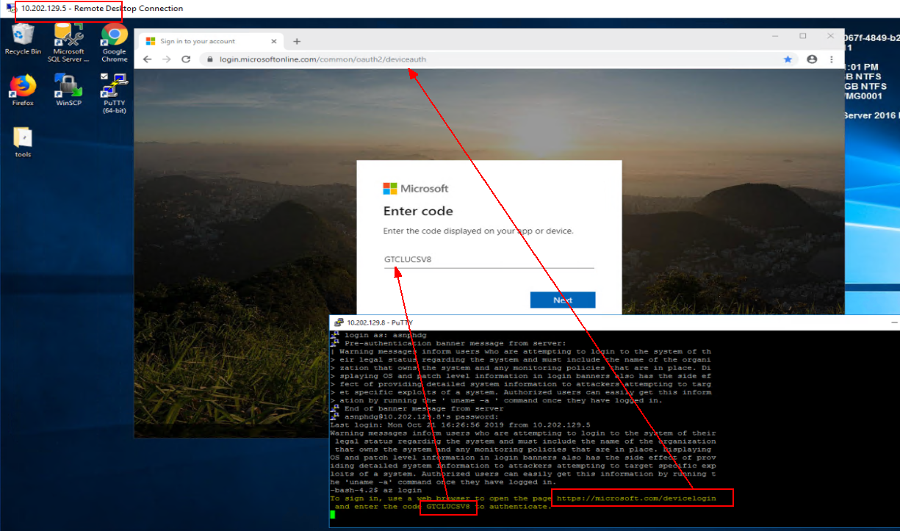

1. Input email account and password of EID and click **Sign in** button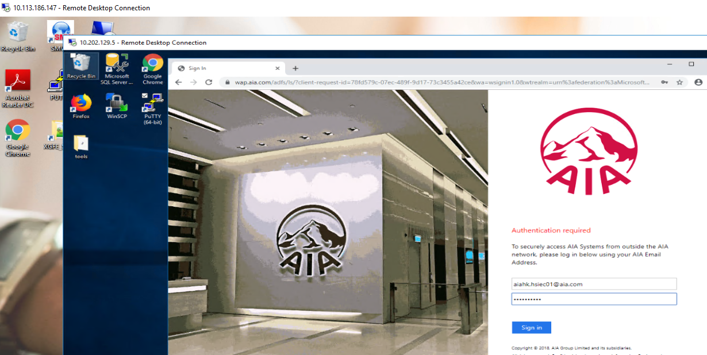
2. After login successfully

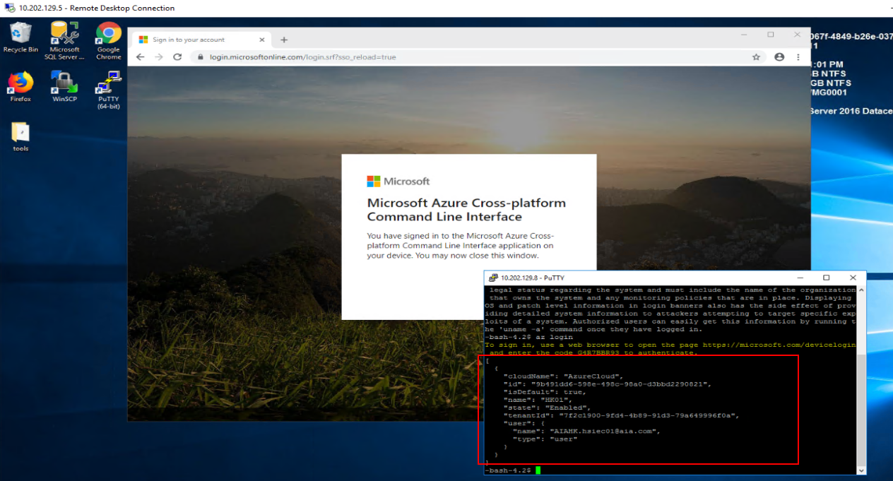

1. Run below command to get AKS credential

**az aks get-credentials --resource-group rg-hk01-eas-u-internet-cont01 --name aks-hk01-eas-u-internet-cu03**

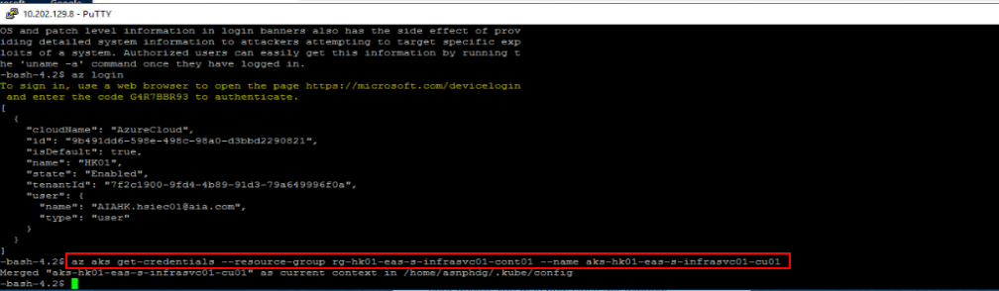

*Supplement

|  |  |
| --- | --- |
| SIT | az aks get-credentials --resource-group rg-hk01-eas-s-internet-cont01 --name aks-hk01-eas-s-internet-cu03 |
| UAT | az aks get-credentials --resource-group rg-hk01-eas-u-internet-cont01 --name aks-hk01-eas-u-internet-cu03 |
| Prod | az aks get-credentials --resource-group rg-hk01-eas-p-internet-cont01 --name aks-hk01-eas-p-internet-cu03 |

1. Run below command to start or scale out application as needed

**kubectl scale --replicas={{number of pods needed}} deploy hk-crm-smart-engine**

Note:

* + To start the Smart Engine with one instance, the following command as an example

**kubectl scale --replicas=1 deploy hk-crm-smart-engine**

* + To scale out the Smart Engine with one additional instance, the following command as an example

**kubectl scale --replicas=2 deploy hk-crm-smart-engine**

* + It is recommended to increase the number of POD one by one to avoid too much data loading on start-up job.

1. Wait for 5 minutes and verify all application instances are running and ready with the following command

**kubectl  get pod -l app=hk-crm-smart-engine**



## System Shutdown procedure (full)

1. Remote desktop to Windows jump Host (for example, 10.202.129.5) from terminal server
2. Login Linux jump host (for example, 10.202.129.8) with tool Putty using account of linux jump host.



1. Azure device login

* Run command : az login
* Open Google Chrome and input URL <https://microsoft.com/devicelogin> , copy code from console and input to UI page, then click Next button.



* Input email account and password of EID and click Sign in button
* After login successfully



1. Run below command to get AKS credential

**az aks get-credentials --resource-group rg-hk01-eas-u-internet-cont01 --name aks-hk01-eas-u-internet-cu03**



*Supplement

|  |  |
| --- | --- |
| SIT | az aks get-credentials --resource-group rg-hk01-eas-s-internet-cont01 --name aks-hk01-eas-s-internet-cu03 |
| UAT | az aks get-credentials --resource-group rg-hk01-eas-u-internet-cont01 --name aks-hk01-eas-u-internet-cu03 |
| Prod | az aks get-credentials --resource-group rg-hk01-eas-p-internet-cont01 --name aks-hk01-eas-p-internet-cu03 |

1. Run below command to stop or scale down application as needed

**kubectl scale --replicas={{number of pods needed}} deploy hk-crm-smart-engine**

Note:

* + To reduce the Smart Engine from two instance down to one instance, use the following command as an example

**kubectl scale --replicas=1 deploy hk-crm-smart-engine**

* + To stop all Smart Engine instance immediately, use the following command

**kubectl scale --replicas=0 deploy hk-crm-smart-engine**

1. Verify application is Stop.

**kubectl  get pod -l app=hk-crm-smart-engine**



## Respective component start-up procedures

### Name of components

#### UP-stream dependency (Check before start-up)

N/A

#### Start-up procedures

N/A

#### Down-stream dependency (Check after start-up)

Down-stream are following

* Azure SQL db_smart
* Azure Redis Cache
* D365 (It is a SaaS, assuming it is always up and running with SLA guarantee)

The application pod status will only become “ready” if all these three downstream are connected correctly during the pod creation. Use the following command to check if the Smart Engine POD instance’s “ready” status

**kubectl  get pod -l app=hk-crm-smart-engine**

.

## Respective component Bring-down procedures

### Name of components

#### Down-stream dependency (Check before bring-down))

N/A

#### Bring-down procedures

N/A

#### Up-stream dependency (Check after bring-down)

N/A

## Special Service Recovery Procedures (Full)

### UP Stream / Down-Stream dependency (Before recovery)

N/A

### Service recovery procedures

N/A

### Verification procedures after recovery

N/A

### UP Stream / Down-Stream dependency (After recovery)

N/A

## Special Service Recovery Procedures (Name of Component)

### UP Stream / Down-Stream dependency (Before recovery)

N/A

### Service recovery procedures

N/A

### Verification procedures after recovery

N/A

### UP Stream / Down-Stream dependency (After recovery)

N/A

# Data Backup and Archive requirements

## Data Archive requirements

N/A.

Note:

* The data in Smart Engine is always come from EDW via data migration, and therefore the db_smart is not the data golden source. The archive will be handled in EDW.
* No archive required for folder or log file.

## Data Backup requirements

Full database backup is required for SQL Server database db_smart.

Application instances are stateless and does not require backup.

## Data backup procedures

Follow to a standard SQL Server database backup procedure.

Note: Since there is no transaction in database, Smart Engine downtime is not required.

## Data Restoration procedure

Follow to a standard SQL Server database restoration procedure.

After full restoration, operator verifies and checks the database tables existence and data volume with application team.

# Application Monitoring Requirements

## Infrastructure Monitoring and Alerts

### Items to be monitored and alert thresholds

**CPU - Smart Engine (AKS - aks-hk01-eas-p-internet-cu03)**

|  |  |  |  |
| --- | --- | --- | --- |
| AKS - Deployment | Notification Threshold | First Level Support | Escalate |
| hk-crm-smart-engine | 20minutes average > 70% | Wong, Rosa-PS <rosa-ps.wong@aia.com> | Terrence-HT, Leung <terence-ht.leung@aia.com> |

**Memory - Smart Engine (AKS - aks-hk01-eas-p-internet-cu03)**

|  |  |  |  |
| --- | --- | --- | --- |
| AKS - Deployment | Notification Threshold | First Level Support | Escalate |
| hk-crm-smart-engine | 20minutes average > 80% | Wong, Rosa-PS <rosa-ps.wong@aia.com> | Terrence-HT, Leung <terence-ht.leung@aia.com> |

### Alert Notification List

## Application Monitoring and Alerts

### Items to be monitored and alert thresholds

Database – **db_smart (**sql-hk01-eas-p-infrasvc01-srv01.database.windows.net )

|  |  |  |  |
| --- | --- | --- | --- |
| Monitoring Activities | Threshold | First Level Support | Escalate |
| Database Size | 1440 minutes average > 50% | Wong, Rosa-PS <rosa-ps.wong@aia.com> | Terrence-HT, Leung <terence-ht.leung@aia.com> |
| Database DTU | 20minutes average > 70% | Wong, Rosa-PS <rosa-ps.wong@aia.com> | Terrence-HT, Leung <terence-ht.leung@aia.com> |

### Alert Notification List

The alert will be sent to an email group below

**AIAHKRptGrpITCRMSupport@aia.com**

### Monitoring and Investigation Mechanism

The following workflow describes the monitoring and investigation mechanism.

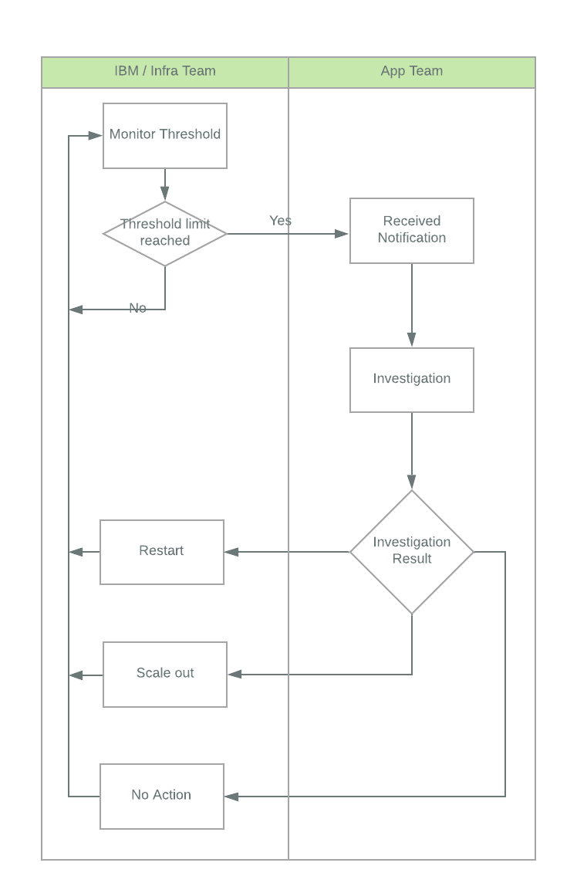

<End of Document>